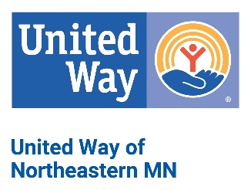

Endorsement Letters: New Hires

Below is a sample endorsement letter to promote your United Way campaign in the workplace. Be sure to put this on your company letterhead and personalize it whenever possible for greatest impact.

Dear (NEW EMPLOYEE NAME):

Congratulations and welcome to (COMPANY)! You are an important addition to our team, and we are confident that you will enjoy and grow from your experience here. Today you have the opportunity to join us in something we are very proud to be a part of - supporting United Way of Northeastern Minnesota (UWNEMN).

We hope one of the reasons you chose (COMPANY) is our commitment to our employees and our community. One of the ways we follow through on that commitment is by supporting UWNEMN. We truly believe that supporting our local United Way allows us to help build a stronger community by improving lives. Our dollars stay local and help our neighbors, friends, family, and co-workers.

Your support impacts the lives of thousands in our region by providing financial support to local non-profit agencies and UWNEMN programs like:

- Buddy Backpacks – providing weekend meal kits to food-insecure children
- United for Veterans – supporting local veterans and their families
- Imagination Library – free books for children from birth to age five
- Meet Up and Chow Down – free summer lunch for children
- Comforts of Home – donated household products provided to those in need
- Smiles United – dental care for uninsured or under-insured people of all ages
- Lunch Buddies – one-on-one mentoring for elementary school students

We are excited that you have joined our team. You can help us Make Great Things Happen by Giving Where You Live, filling out the enclosed pledge form and returning it to (HR DEPARTMENT).

Together, we can empower healthy lives, help children succeed, and stabilize families and individuals in our region, making northeastern Minnesota a better place to live, work, and play.

Thank you,

(MANAGER NAME & SIGNATURE)

